# **Rest Assured Workshop**

### **Task 1 : Run the Local JSON Server and Perform the Crud**

* Install NodeJS
* Install JSON server globally
* Run Command - npm install -g json-server
* Create db.json from here.
* Run - Json-server db.json

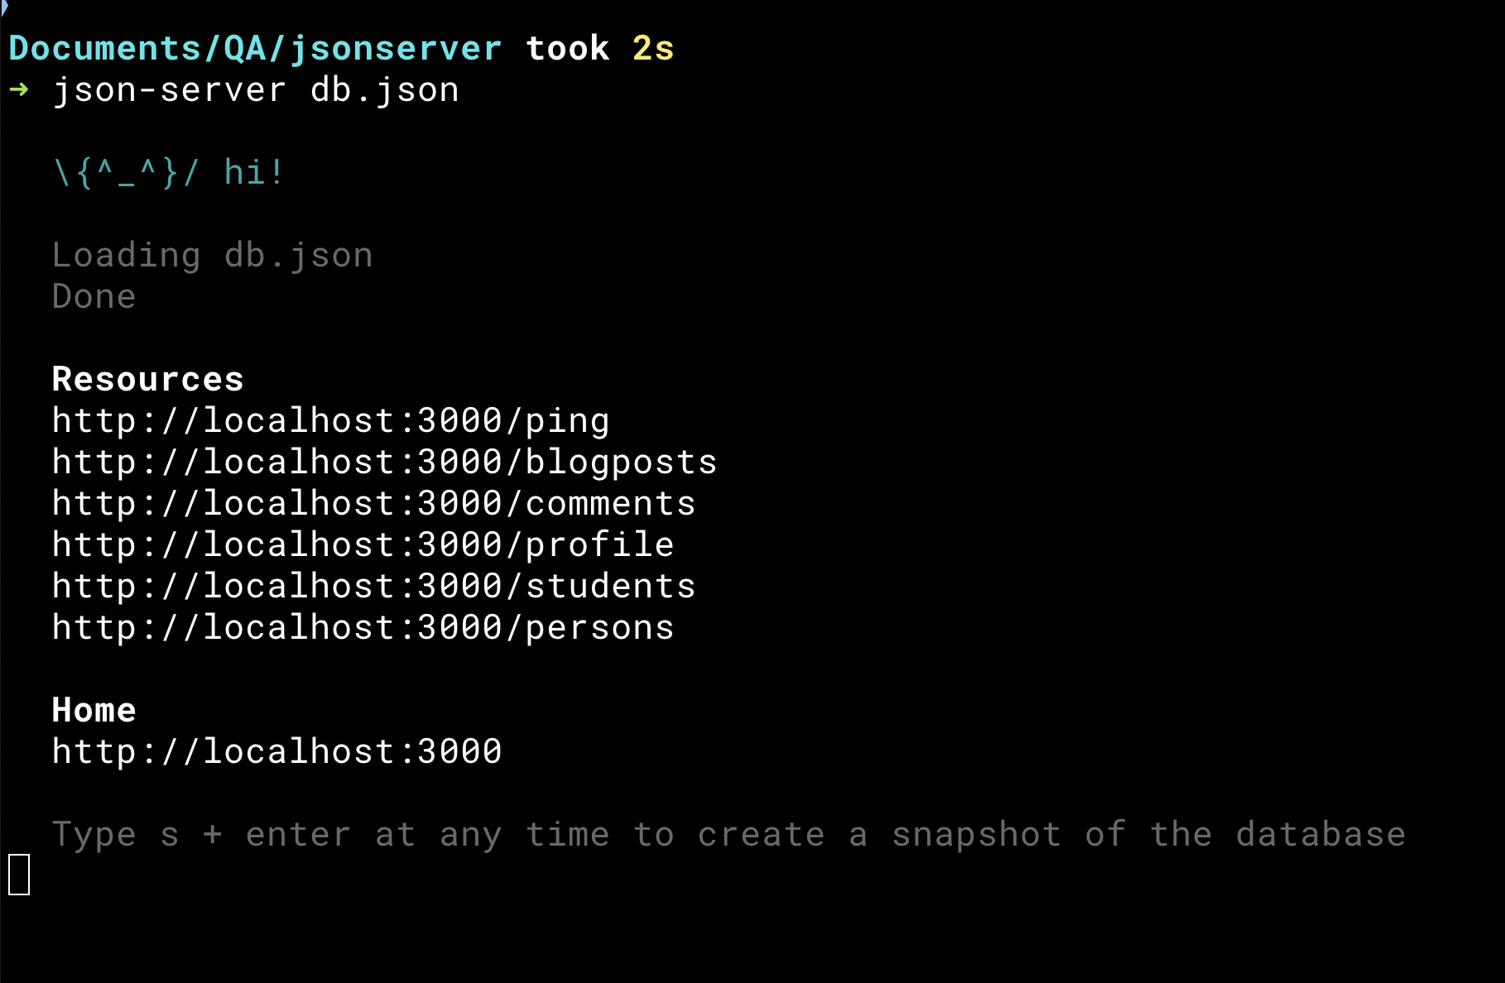

**Postman Collection**

Task 1 : Local JSON Server

## API Testcases

Write Testcases for Post API Testing

<Write here….>

* Verify X when I do Y

## Solution :

1. Actual Result with Expected Result.
2. Keys validation
3. Json Schema Validate
4. HTTP Status
5. Invalid POST verify ( -ve case)
6. Id created not Null
7. Time Taken for HTTP request
8. Verify how the APIs error codes are handled.
9. Verify the Parse the Response data
10. Verification of APIs with Data parameters. (DDT)
11. Validate the keys with the Min. and Max range of APIs (e.g maximum and minimum length)

**Integration Testing Flows (Chaining Request verification.)**

1. Create a Post(with POST Request) and verify it by GET call by Id
2. Update the Post with PUT call and Verify it by GET Call
3. Delete the Post and Verify it doesn’t Exist.

**Security Test Cases**

1. No Authentication.
2. XSS or vulnerable payload to APIs
3. Headers, Content Type.

**Performance Test**

1. What if I send 10 GET requests per second?
2. How does the server behave if we create 50,000 Post in 10 min?
3. What will happen if 10 GET calls per second for 1 hour?